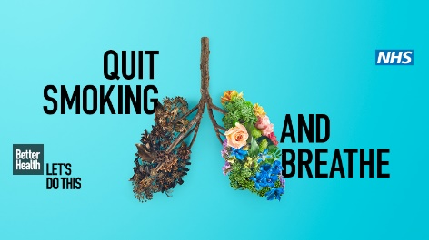

**PARTNER UPDATE**

**LiveWire’s Supports Better Health Stoptober 2020**

Now in its ninth year, Stoptober is back for 2020 with a fresh new creative design to encourage the nation’s smokers to make a quit attempt. As with previous Stoptober campaigns, our aim is to support smokers to quit for October and beyond, based on the evidence that if a smoker can quit for 28 days, they are five times more likely to quit for good.

LiveWire Lifestyles & SmokeFree Warrington have continued to deliver services remotely to all residents and workers in Warrington and we hope this acts as a reminder that we are continuing to accept referrals in the traditional sense for Smoking Cessation, Weight Management, Condition Specific Exercise and Cancer Rehab.

**How else can you support the campaign?**

Whether you’re a local partner organisation, GP practice, community pharmacy, NHS Trust or commercial organisation, we hope you’ll join us in supporting smokers to make a quit attempt this Stoptober.

Warrington’s campaign will be predominantly virtual with support given to residents via Facebook or over the phone. Our SmokeFree Warrington social media page will include daily tips and resources to support people to quit and we hope you will support us by sharing this information and encouraging your users on your organisations social media platforms to access the service and using the hashtags; #BetterHealth #Stoptober2020 #SmokeFreeWarrington when you share.

Posts have already been published as part of the rally phase in the build up to 1st October and we are happy for you to replicate or distribute these to your followers. Further activities will be published from 1st October for the duration of the month including, Facebook Live sessions and group Stoptober Zoom calls for anyone wishing to know more about the campaign. To gain access to the page visit <https://www.facebook.com/Smokefreewarrington/>

We’d also love to see how else you’re get involved. Please share examples of your local activities with us by sending details or photos to [**stopsmoking@livewirewarrington.org**](mailto:stopsmoking@livewirewarrington.org)so that we can include your information in a closing press release at the end of October. Electronic resources to support organisations like posters, GIFYS and digital displays can be emailed across too - If you wish to access this, please send us an email on the above address and an advisor will be in touch.

Finally, there are a number of new training links for professionals to access to support staff to deliver appropriate tobacco control interventions. All Public Health training opportunities are currently being delivered remotely and can be booked via the following link <http://www.warringtontraininghub.uk/publichealthtraining>

Thank you for your **support.**

For information on SmokeFree Warrington, the service we provide and other LiveWire services available, visit livewirewarrington.co.uk/lifestyle or call 0300 003 0818.

**Thank You for your continued support**

**LiveWire’s SmokeFree Warrington**

**For more information or interview requests, please contact Ruth Armstrong (SmokeFree Warrington Lead) on 0300 003 0818 or** [**rarmstrong@livewirewarrington.org**](mailto:rarmstrong@livewirewarrington.org)

**About LiveWire:**

LiveWire is a Community Interest Company (CIC) that has been managing leisure, library and lifestyle services in Warrington since May 2012. The organisation is now the largest provider of leisure and library facilities in the town, operating three neighbourhood hubs, three leisure centres, and 12 libraries which have attracted more than three million visitors over the last year.

LiveWire strives to promote a healthy lifestyle, increased participation in activities whilst encouraging reading and learning through the use of free access to books, IT suites and the internet.They provide value for money leisure memberships and are committed to ensuring facilities and activities are accessible for all members of the community.